**Create two table employee and department for join operations.**

**Inner join:**

select e.emp_id,e.emp_name,e.salary,e.dept_id,d.dept_name

from employee e inner join dept d

on e.dept_id=d.dept_id;

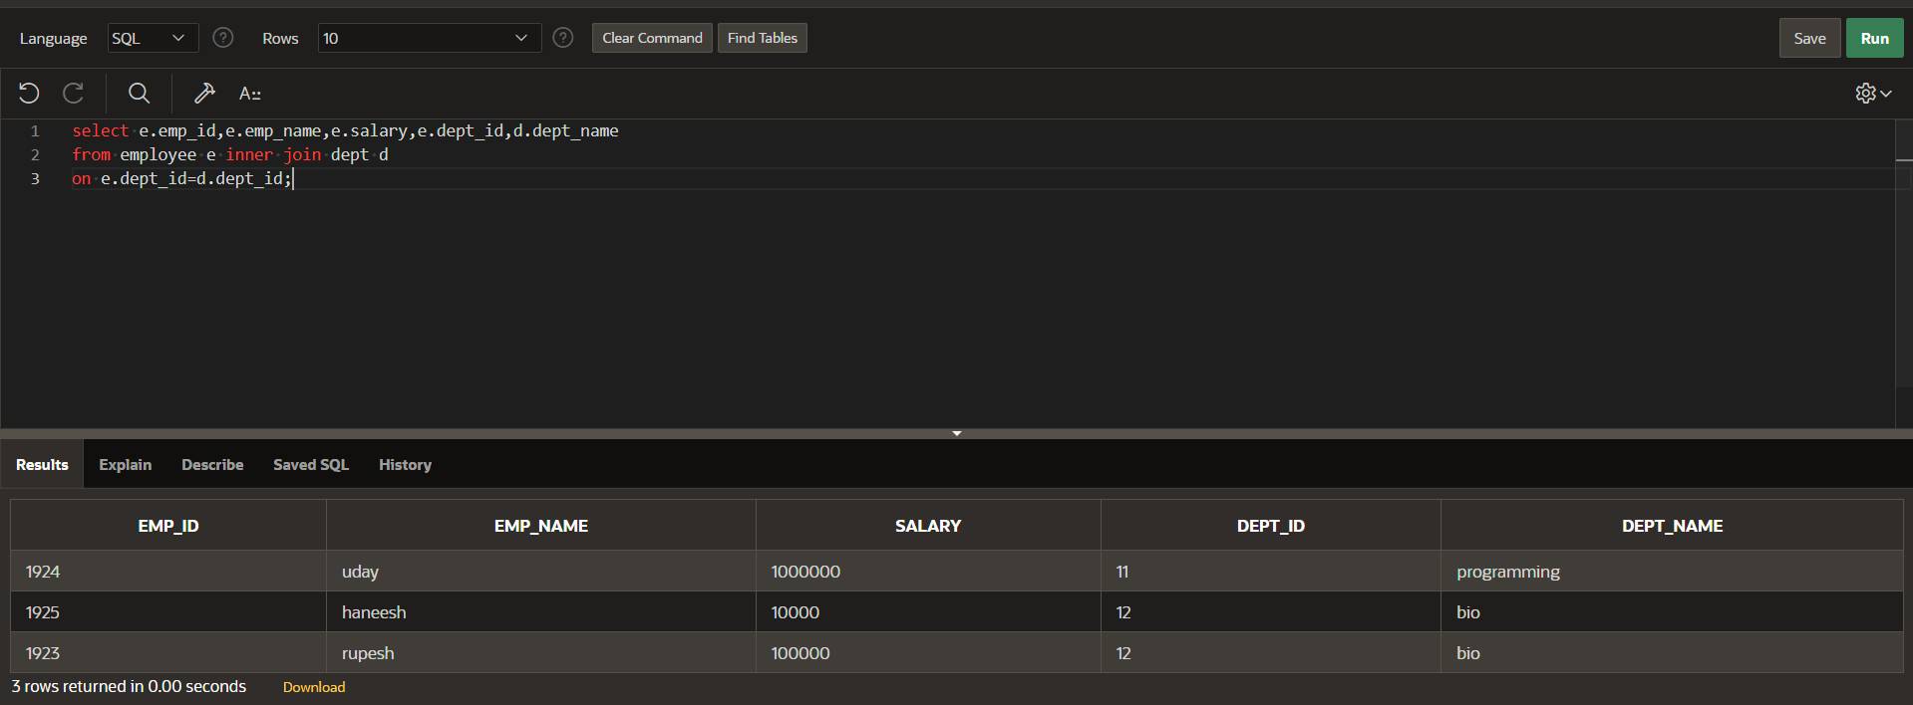

**Left join:**

select e.emp_id,e.emp_name,e.salary,e.dept_id,d.dept_name

from employee e left join dept d

on e.dept_id=d.dept_id;

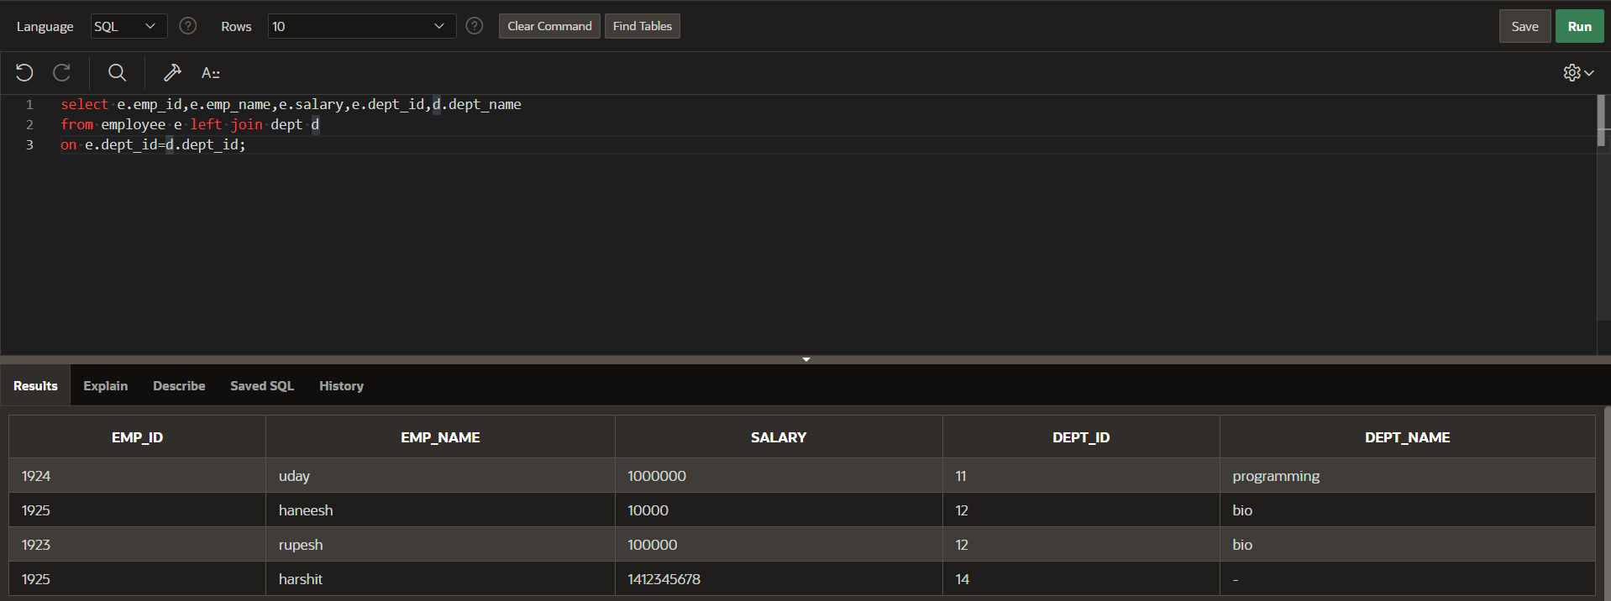

**Right join:**

select e.emp_id,e.emp_name,e.salary,e.dept_id,d.dept_name

from employee e right join dept d

on e.dept_id=d.dept_id;

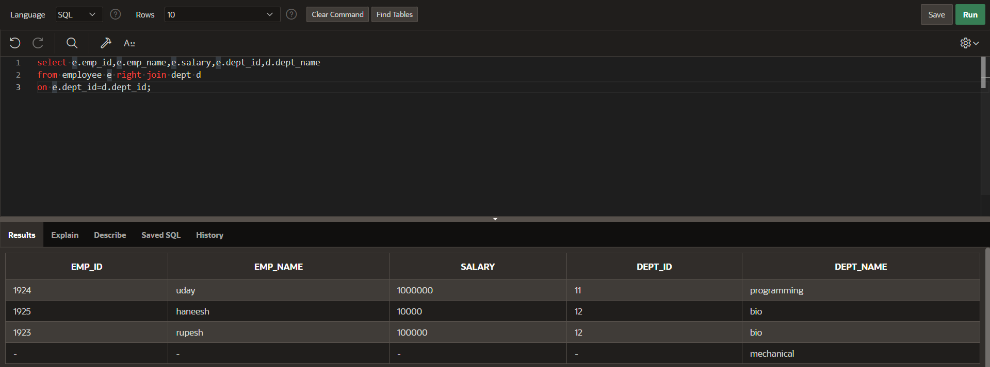

**Full join:**

select e.emp_id,e.emp_name,e.salary,e.dept_id,d.dept_name

from employee e full join dept d

on e.dept_id=d.dept_id;

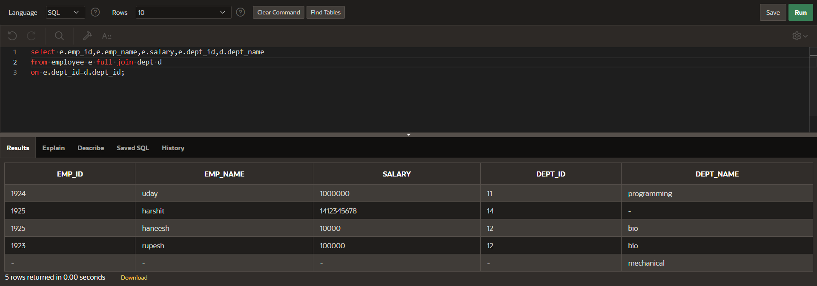

**Natural join:**

SELECT emp_id,emp_name,salary,dept_id,dept_name

FROM employee NATURAL JOIN dept ;

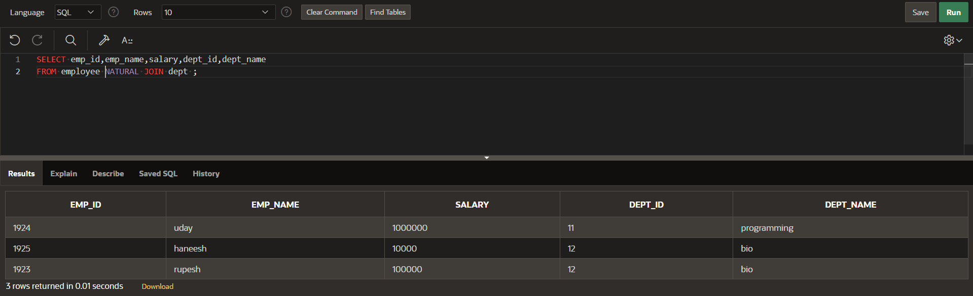

**Self join:**

SELECT e1.emp_id, e1.emp_name, e1.emp_phone, e1.emp_place, e1.dept_id, e1.salary,

e2.emp_name AS manager_name

FROM employee e1

LEFT JOIN employee e2

ON e1.dept_id = e2.dept_id AND e1.emp_id != e2.emp_id;  
